



 

 

 

 

 

 

 

 

 



 

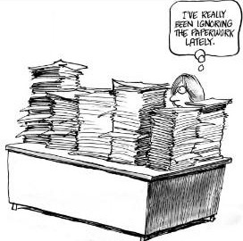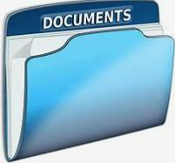

 

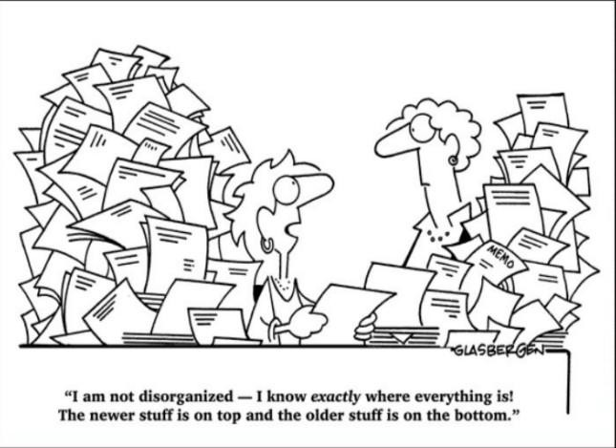

What is Documented Information?

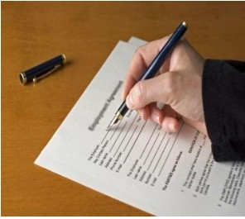

**D** Evidence of Conformity Provision of evidence that what was planned has

actually been done.

Documents may be in any form or type of medium:

* Paper

**x** • Electronic



**x**

* Photograph
* Master sample

**Newly Hired Document Contrroller**

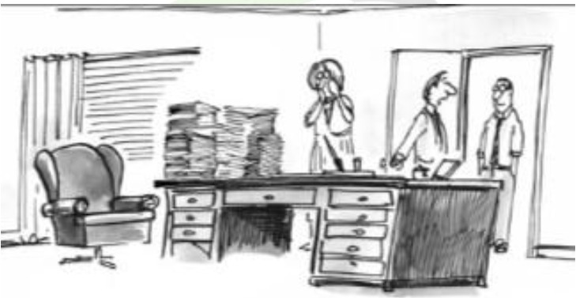

"'I ..**llMI** •••**IBtalli I I m** .......... ......**c.a."9'•**



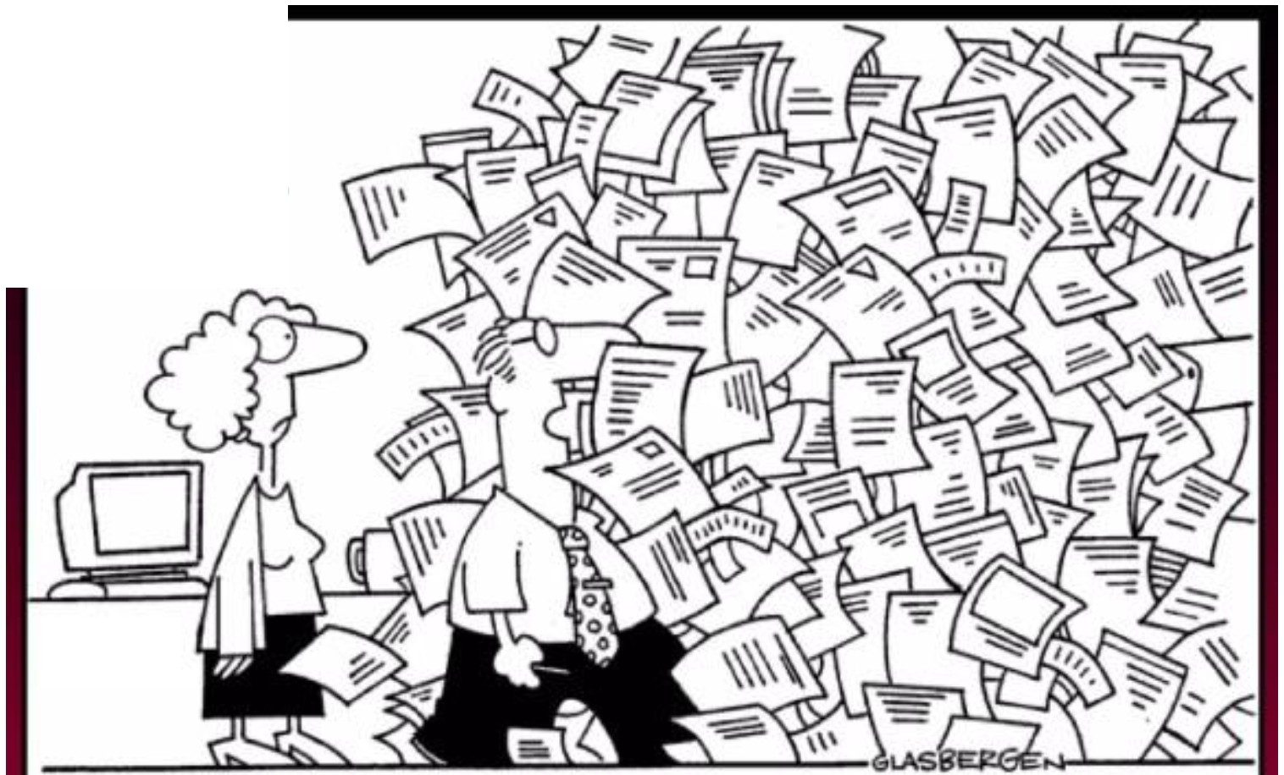

**fte,r a**

**W1e** k...

I hav om p p rwork to tch up. lf I'm not b

in two days organize a earch and re cue team!"

**Reminder !**



###### ISO requires (and always *has* required)

a *"Documented quality management system",*



*"Ican't rmrtmbtr'-do I worlt.* "' *homt or do I liw at worlt.t"*

and not a *"system of documents".*

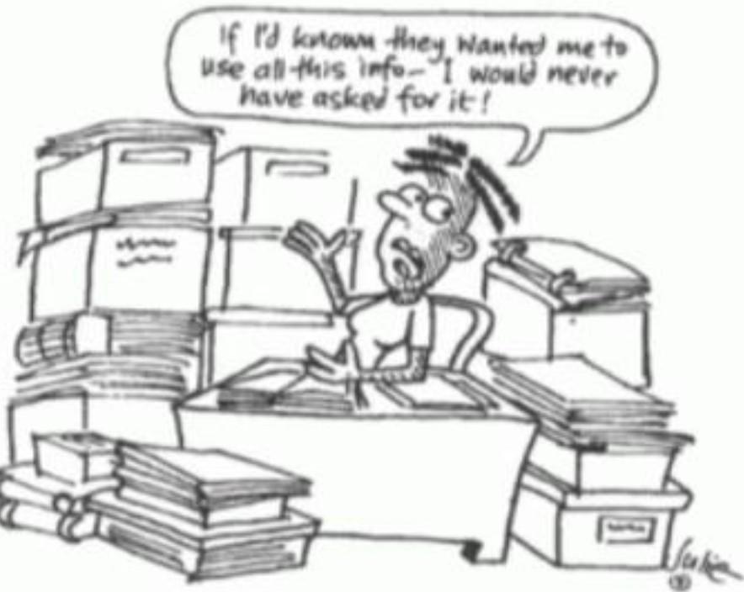

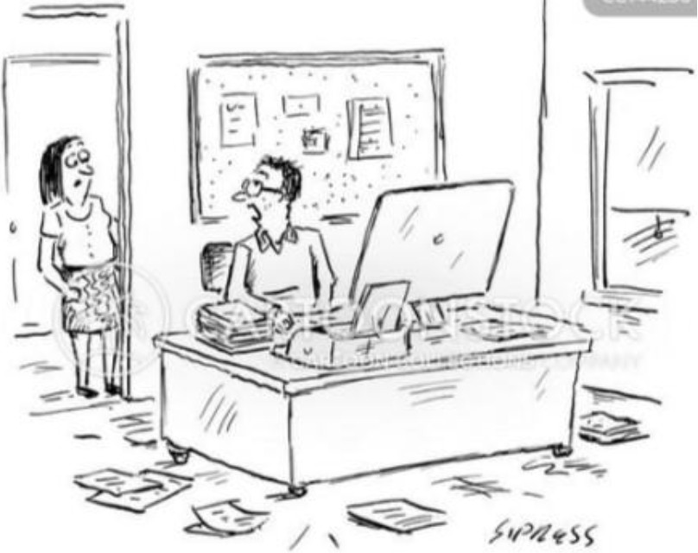

Reminder !

Organizations are free to develop other records that may be needed to demonstrate conformity of their processes, products and services and quality management system.

How many more doaJl'TW?nts do you think we need to Cl"e(lte?

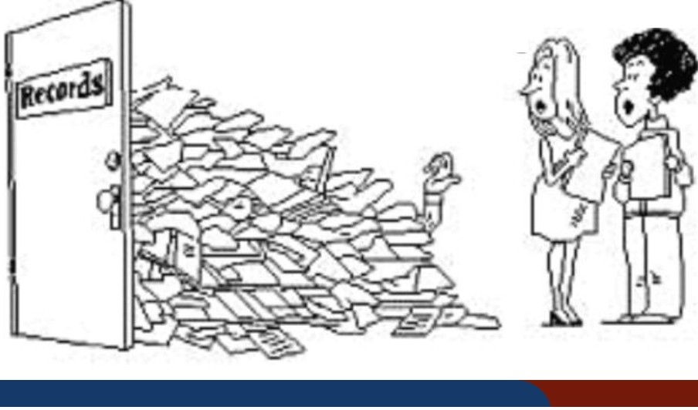

.............

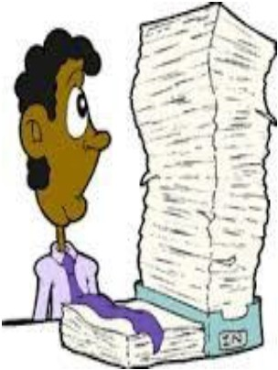

Good Documentation Practices (GDP)

Documentation becomes legal proof that activities were performed as intended and that products or services meet quality and safety standards. GDP ensures that:

Every action is traceable - who did what, when,and why.

Records are legible, permanent, and authentic - no unauthorized alterations.

Documentation is contemporaneous - completed in real­ time, not in retrospect.

Errors are corrected transparently - with single-line strike­ throughs, signed and dated.

Compliance is verifiable - by internal audits or regulatory authorities (e.g.,FDA, ISO,WHO).



**The error maker should be the one to correct the error.**

* The person who origina lly made the entry has the best understa nding of what the intended entry was and is in the best position to correct it accurately.

**If that person cannot be found, then management approval is required for the correction.**

* In such cases, a supervisor or manager (ideally the QA or Compliance Officer) must authorize a nd document the correction with a proper explanation a nd reference.



**Good Documentation Practices (GDP)**

' ***Scenario:*** A lab technicia n, Anna, mistakenly wrote the wrong batch number on a qua lity control log sheet.

**LI *Correct Practice:*** Anna notices the error and performs a

single-line strike-th rough, writes the correct batch number beside it, initials, dates, a nd notes "transcription error."

**(S) *Incorrect Practice:*** Her supervisor, noticing the error, corrects

it himself without consulting Anna or leaving a ny tracea bility - violating



traceability and accounta bility.

Don't recopy data just to make it look 'nice.

* Rewriting data violates traceability principles. Once data is recorded, a ny correction must follow the proper error correction procedure
* e.g., single line strike-through, reason for change, initials, a nd date.



What documentation errors are common in your area?

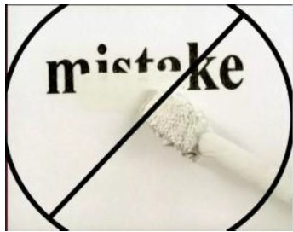



Good Documentation Practices (GDP)

Making Corrections

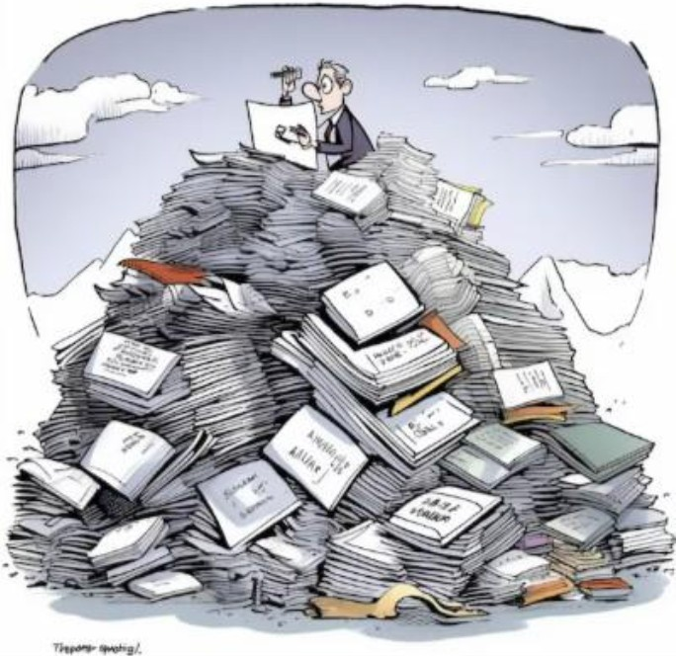

* State reason for corrections D RE: Recording Error

D TE: Technica l Error D CE: Calculating Error

D Ml: Malfunctioning Instrument D SE: Spelling Error

D WD: Wrong Date

D TE: Tra nscription Error



./ Why Implementing GDP Is Essential

*Y* Good Documentation Practices are not just about "writing things down."

*Y* Foundation of quality and compliance.

*Y* They are about building a culture of accuracy, integrity, and accountability that supports both daily operations and long-term compliance.

"' Implementing GDP is essential to: 1.Prevent data manipulation or fraud.

* 1. Ensure accountability and enable root-cause analysis when issues arise.
  2. Support audit readiness and maintain regulatory certifications or accreditations.
  3. Facilitate reliable decision-making based on credible records.



5.Protect public health and safety by ensuring quality in

processes and outcomes.

#### 3Ps of Documentation

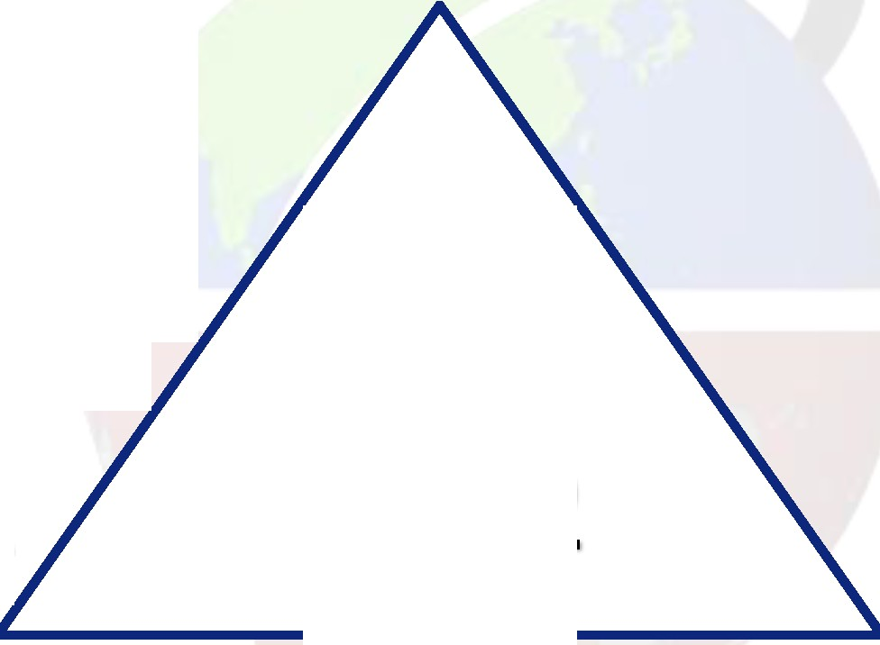

The Foundation of Quality System

People

**Who**

*Document Controller*



 



 

 

 

 

 

 



 

 



 

 

 



 

 

 

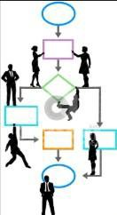

Process

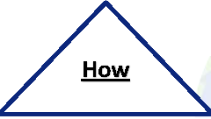

The Blueprint for Consistency and Efficiency

)- Input > Process > Output

Process: *Specimen Receiving and logging*

Input: Arrival of sample with request form

Process: Verify label -7 Log in LIS -7 Stamp timestamp -7 Assign to analyst

Output: Accessioned sample ready for testing

)- Competence Competence: Specimen Receiving Clerk

Indicator: 100% of samples logged within 10 minutes of receipt

What are the pot,ential risks and contr'ols?

3Ps of Documentation

Process

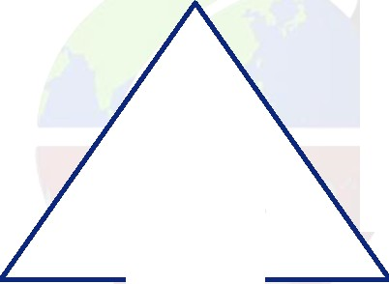

**What** Pape?

The Proof of Compliance and Conformance

Paper ')

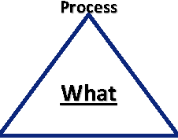

The Proof of Compliance and Conformance

)- The documentation and records that serve as objective evidence.

)- Proof of compliance and existence.

./ ISO 9001:2015 -Triggers and

./ Organizational Requirements-Skilled and Competent

./ Customer Requirements- Awareness

./ Regulatory Requirements - Involvement and Engagement



##### 3Ps of Documentation

The Foundation of

**Who**

**Without pr Ion \'MPH cannut prCl\'e compllanee nor mdence of lmplementatlon to ISO 90e1**

# Procen

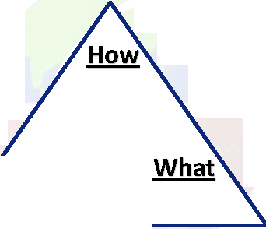

The Blueprint for

Consistency and Efficiency

Pape?

Quality System

**People**

'

The Proof of Compliance and



Conformance

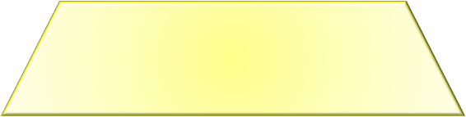

 

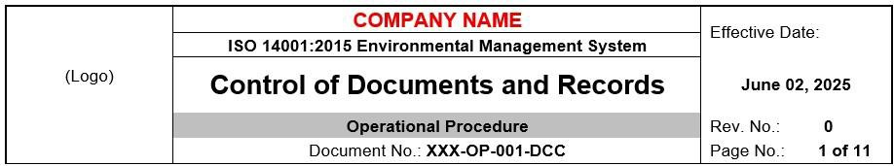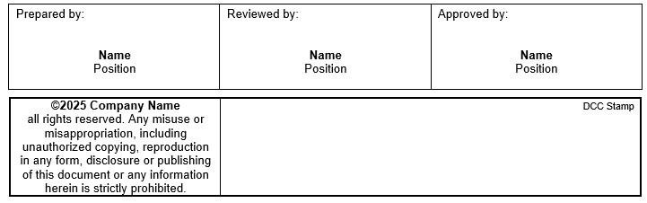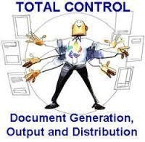

 

 

 

 

 

 

 

 

 

 

**How to Determine needed Documentation?**

Organizations prepa ring to implement a MS

**TOTAL CONTROL**



For organization that are in the process of implementing or have yet to implement a Management System emphasizes a process approach.

This includes:

* Determining the processes necessary for the effectiveness implementation of the quality management system.
* Determining the interaction between these processes.

Document Generation Output and Distribution



**Organizations preparing to implement a MS**

Document the processes to the extent necessary to assure their effective operation and control. It may be appropriate to document the processes using process mapping tools.

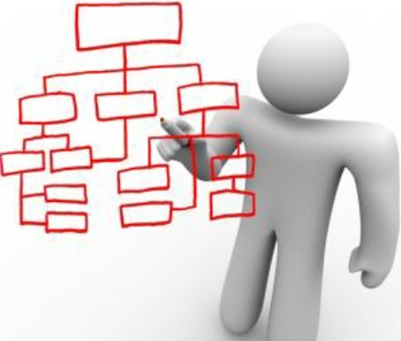



### Organizations preparing to implement a MS

* + Analysis of the processes should be the driving force for defining the amount of documented information needed for the management system, taking into account the requirements of ISO as applicable.



* + It should not be the documented information that drives the processes.



**DOCU M ENT**

*M/'****it's not documented correctly, it didn'thappen."***

**Good Documentation Practices (GDP) are a set of quality assurance principles designed to ensure the integrity, accuracy, and reliability of documented information in regulated environments such as healthcare, diagnostics, manufacturing, and laboratories.**



**INTRODUCTION - ALCOA**

'YThe acronym ALCOA originally emerged in the early 1990s from the U.S. Food and Drug Administration (FDA) during its guidance on data integrity in pharmaceutical and clinical research documentation.

'Y lt was used to describe the essential characteristics that data and records must have to be considered trustworthy and acceptable during inspections .

../ Attributable - Who did it?

../ Legible - Can it be read?

../ Contemporaneous - Was it recorded at the time?

../ Original - Is it the first-hand record?

../ Accurate - Is it true?

These principles were applied to both paper-based records and electronic data systems.



## ALCOA + Principle

ALCOA+ Principle

**LI** Attributable

**LI** Legible

Definition

Clearly indicate who performed the action and when.

Documentation must be readable and understandable to others.

GDP Relevance

Initials/signatures, time­ stamps, user logins

No smudges, no abbreviations unless defined

**LI** Contemporaneous

**LI** Original

**LI** Accurate

Recorded at the time of the Avoid backdating or post- activity. event entries

The first-hand recording, Source documents, not not a copy or duplicate photocopies without unless validated. authentication

Must reflect the true and No guesswork, rounded exact details of what values, or post-hoc edits occurred. without note



Documented Information

TRAINING

Q & A

**FEEDBACt**

YEARS OF CREATING

-QUALITY AND

EXCELLE

*r*

Documented Information



TRAINING

**Thank you!**

YEARS OF CREATING



-QUALITY AND

E LE

. ;

' I. .:1.;'..,,,.

-: